**IN615008:**

**Switching, Routing and Wireless Essentials**

**Assignment (40%)**

**Student Name: Anthony Legg**

**Due Date/Time:** 5pm, Friday 28 May

A 10% penalty will be applied for each day late.

**Course credits: 15**

**Level: 6**

**Instructions**

You are required to complete this assignment and submit a digital copy of this document, along with the Packet Tracer file of the completed network configuration. Your digital copy of this document should include the answers to all questions as indicated. The two files will need to be emailed to [mholtz@op.ac.nz](mailto:mholtz@op.ac.nz) by the date/ time listed.

**Learning Objectives**

1. Design and build a network for availability and redundancy.
2. Configure and troubleshoot flexible local area networks using virtual and wireless technologies.

**Background**

Choam Corporation is redesigning its network to take advantage of a hierarchical network design and the performance and scalability benefits of OSPF. You have been requested to carry out the redesign and ensure it meets all specified requirements.

The physical topology has already been decided upon. You are required to made decisions about the logical topology and create the resulting network within Packet Tracer for testing purposes. Choam Corporation has also requested that you answer some questions pertaining to the design, the technologies employed and possible future direction.

**Requirements**

The network is to be comprised of a Head Office (HO) LAN that is connected to the internet and one additional remote WAN site. The HO LAN utilises a collapsed core architecture which combines both distribution and core layers.

**HO Requirements**

* 4 user VLANs (Finance, Sales, Personnel, Admin). Each user VLAN is a /27 IP network. Ensure these networks can be summarised in as small a contiguous block as possible.
* 1 server VLAN. The server VLAN will require a maximum of 12 usable IP addresses.
* Use private IP addressing from 192.168.11.0/24 unless otherwise specified.
* The company wishes to conserve IP Addresses where possible for future use. Therefore you must use VLSM for IP addressing.
* All HO switches require a management address within a dedicated management VLAN. The management network is a /28 IP network.
* OSPF will run between the WAN edge routers and between HO and Site1.
* Access and Distribution switches are layer 2 (2960) switches.
* You are required to decide upon a naming convention, for the network devices and the end hosts, that is logical and consistent.
* 4 servers in a dedicated VLAN will be connected to the same access switch.
* For the purpose of the packet tracer proof of concept, only 1 PC per user VLAN is required on each of the non-server switches.
* Further requirements are outlined in each section below.

**WAN Site-1 Requirements**

* Use private addressing from 192.168.21.0/24 unless otherwise specified.
* 4 employees in the Site1 Finance department.
* 15 employees in the Site1 Sales department.
* All switches require a management address allocated from within an appropriately sized VLAN.
* You must use VLSM for IP address allocation.
* All switches are Layer 2 switches.
* You are required to decide upon a naming convention, for the network devices and the end hosts, that is logical and consistent.
* There are no servers located in Site1.
* Further requirements are outlined in each section below.

**IP address assignment**

* All PCs will be dynamically assigned IP addresses.
* All other IP addresses will be statically assigned.

**Network Topology**

The physical topology is shown here. Link status indicators are not accurate as the devices shown are not configured.

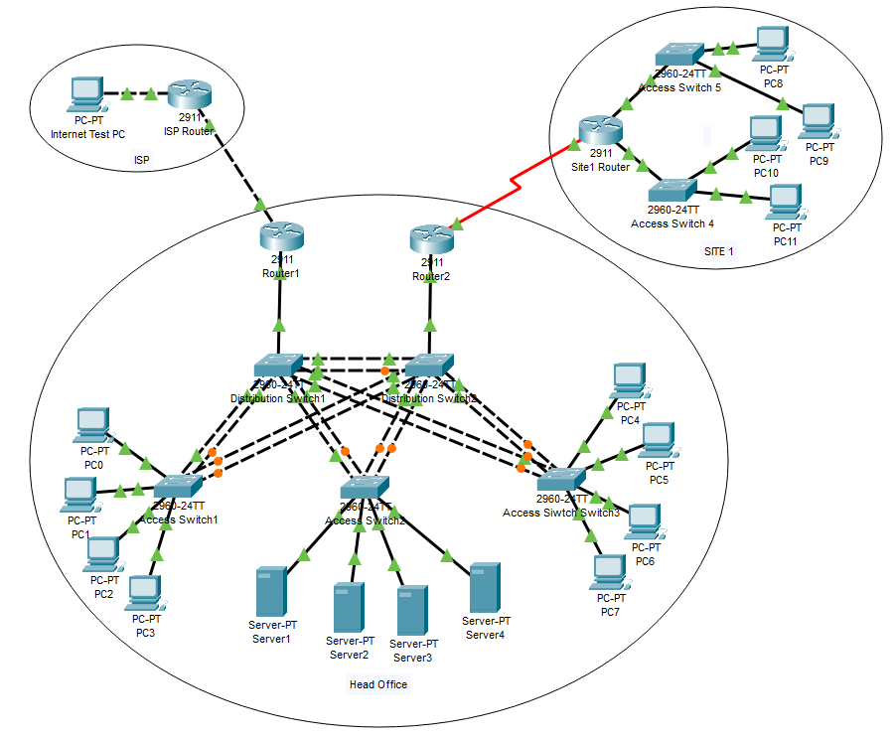

**Section One: Document Logical Design [21 marks]**

1. You are required to produce documentation (use tables) for the following:

* All device names
* All IP Networks (include Network IP, Default Gateway, Broadcast, Max usable hosts, mask, purpose). Note you will need to perform subnetting as required to create the required number of networks outlined in the above specifications.
* Interface addressing (all statically assigned addresses of routers, switches and servers)
* VLAN interface assignment

[16 marks]

1. Describe the three layers of the hierarchical network design model and list the advantages it provides. [5 marks]

The three layers are core, distribution, and access. The core layer features high speed data forwarding, provides redundancy

The distribution layer

The access layer

Advantages of this hierarchical design

**Section Two: Head Office LAN [67 marks]**

1. Cable 3 access layer switches and 2 distribution switches (all are 2960 Layer switches). Ensure the access switches are cabled to each distribution switch. Ensure the distribution switches are cabled to each other. Ensure an adequate number of cables are used to facilitate etherchannel in step 9. [5 marks]
2. Ensure the switches are correctly configured with a hostname, management address and default gateway. [5 marks]
3. Configure the LAN for Rapid-PVST+. Configure the 4 User VLANs, Server VLAN and a Management VLAN. Choose and configure a switch to be the root bridge for the 4 User VLANs and the second switch to be root for the remaining VLANs. Choose and configure secondary root bridges for each VLAN. [15 marks]
4. Describe how the root bridge, designated ports and root ports would be determined by default. Provide captured output to confirm the root bridge in your topology. [10 marks]
5. Cable and configure at least 1 PC per User VLAN on two of the access switches. The PC IP addressing is dynamic. [5 marks]
6. Cable and configure 4 servers in the Server VLAN on the remaining access switch. Use static IP addressing. [5 marks]
7. Ensure all appropriate ports have port-fast configured. What is the purpose of this command? [5 Marks]
8. Ensure all appropriate ports have BPDU-guard configured. What is the purpose of this command? [5 marks]
9. Implement PAgP and 802.1q trunking between the two distribution switches ensuring at least 2 physical cables are used. Implement LACP and 802.1q trunking between each of the access switches and distribution switches (2 physical links per channel). In your documentation provide captured output showing which ports have been aggregated and the type of aggregation (for all port channels). [12 marks]

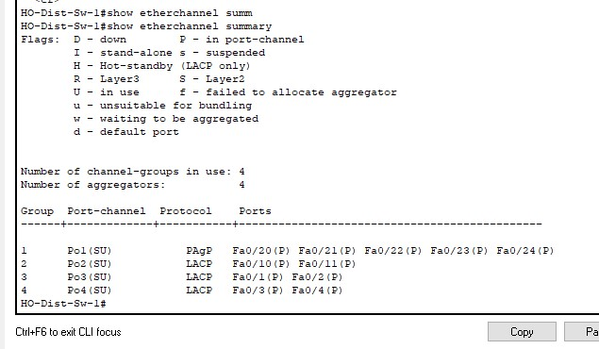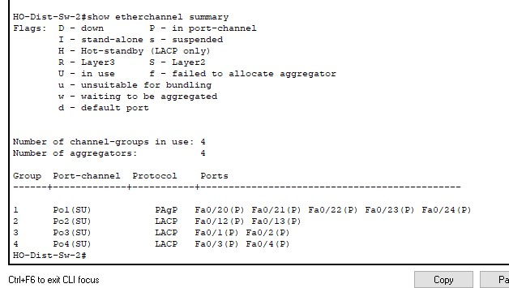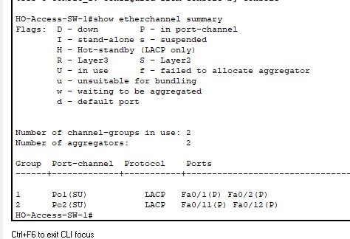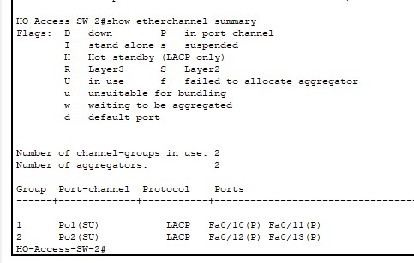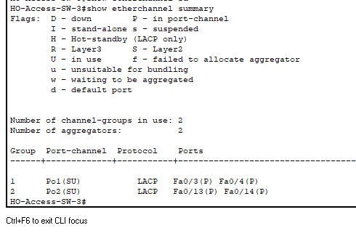

**Section Three: Head Office Routing [58 marks]**

1. ~~Add 2 head office routers. Each router is cabled to a different distribution switch. Ensure the HO routers are configured with a hostname, logging synchronous, no ip domain lookup & SSH access (including admin user). [5 marks]~~
2. ~~Configure each Router for inter VLAN routing using ROAST. [10 marks]~~
3. ~~Configure HSRP for each VLAN. Ensure that the active gateway is connected to the root bridge for that VLAN. [10 marks]~~
4. ~~Ensure pre-emption is supported~~. Document what this does. [5 marks]
5. ~~Show capture output that displays the standby status on both HO routers. [4 marks]~~

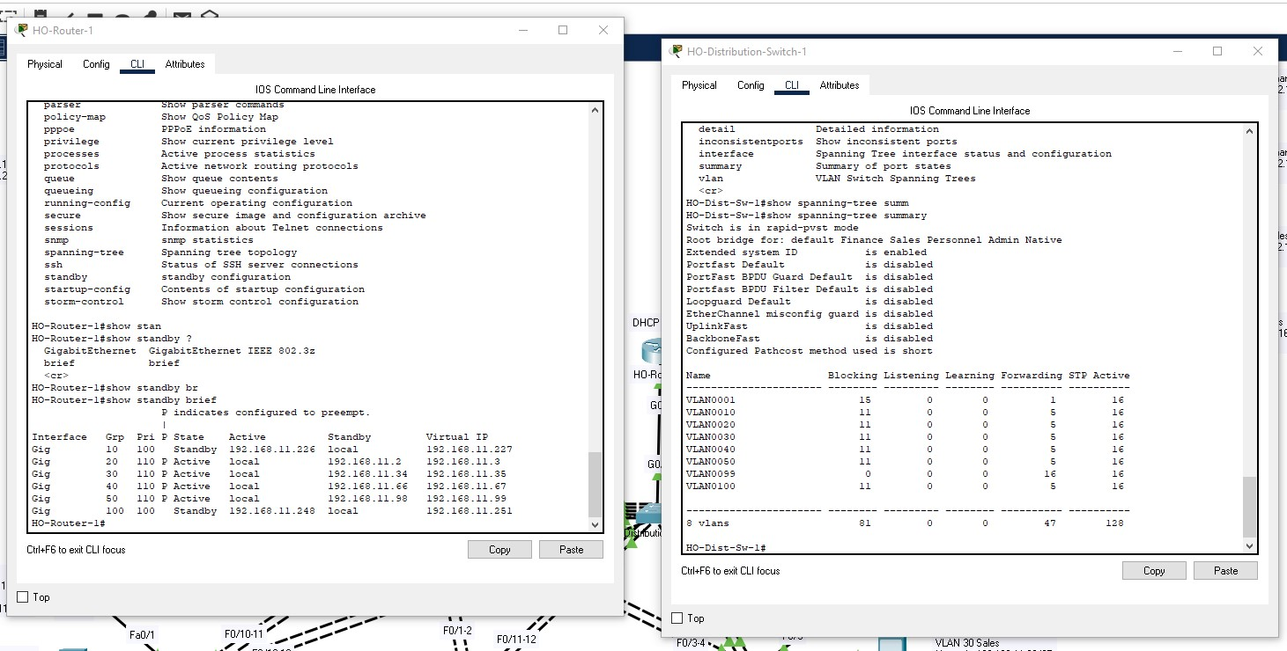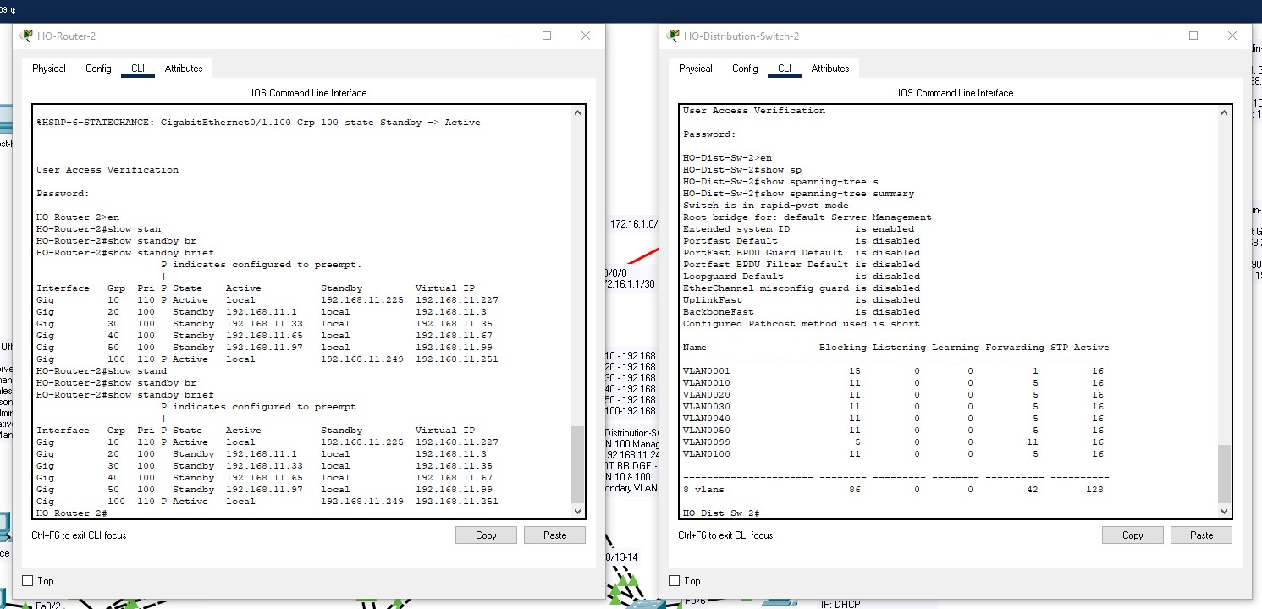

1. ~~Configure OSPF AERA 0 on each router for the HO VLAN networks. Ensure Router-IDs are configured. [10 marks]~~
2. Research the function of DR & BDR roles within OSPF. Explain why they exist and the default process for DR election. ~~Ensure one router is manually configured to be a DR for all its OSPF adjacencies. Provide capture output evidence showing the correct DR relationship for the OSPF adjacencies. [14 marks]~~

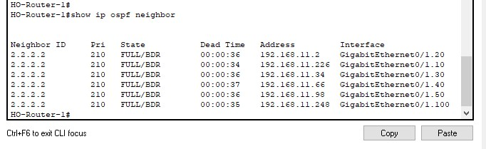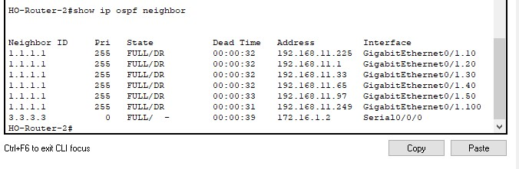

**Section Four: Site1 LAN [13 marks]**

1. ~~Cable 2 access layer switches to the Site1 router (2960 switches). Cable 2 PCs to each Site1 access switch [2 marks]~~
2. ~~Ensure the Site1 switches are correctly configured with a hostname, management address and default gateway. [2 marks]~~
3. ~~Configure the Finance VLAN on one switch and configure Sales on the other. [2 marks]~~
4. ~~Configure 2 PCs per User VLAN. The PC IP addressing is dynamic~~. [2 marks]
5. ~~Configure inter VLAN routing on the Site1 router using ROAST. Note though ROAST is technically not required it is configured to allow for easier future expansion. [5 marks]~~

**Section Five: WAN [19 marks]**

1. Configure the serial link between HO Router2 and the Site1 router. Ensure the clock rate is set to 128000. Use 172.16.1.0/30. [2 marks]
2. Configure OSPF area 1 for the WAN link between HO Router2 and the Site1 router. Ensure router IDs are configured. Show output evidence confirming the OSPF adjacency is operational.[6 marks]
3. Configure the Site1 router to advertise connected VLAN networks via OSPF. Ensure OSPF packets are not sent over LAN interfaces in site1. [6 marks]
4. Configure HO Router2 connected to Site1 to advertise a single OSPF summary address representing the Site1 VLAN networks. Provide evidence output of this being visible on the other HO Router1 (connected to the ISP). [5 marks]

**Section Six: DHCP [17 marks]**

1. Configure DHCP on HO Router2 connected to Site1 to support the 4 HO User VLANs and the 2 Site1 User VLANs. Ensure to exclude addresses that have already been allocated from each subnet to servers and gateways. [8 marks]
2. Configure the Site1 router to allow Site1 PCs to obtain IP addresses from the HO router. [3 marks]
3. ~~Document output from the HO Router2 confirming DHCP leases for HO and Site1. [3 marks]~~

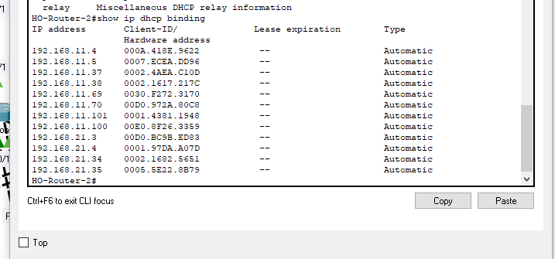

1. Explain the difference between stateless and stateful DHCPv6. [3 marks]

**Section Seven: Internet Routing [10 marks]**

1. ~~Cable ISP router to HO Router1. Configure the ISP router with a hostname. Configure the link between the HO router and the ISP router using the 192.168.1.0/30 network, ensure the ISP end uses the first available IP. [2 marks]~~
2. ~~Configure a static default route on HO Router1 pointing to the IP address assigned to the ISP router end of the link~~. ~~Advertise the static using OSPF. [4 marks]~~
3. ~~Configure a static route on the ISP router for a summary IP network address representing the HO LAN networks pointing to the outbound interface facing HO. [2 marks]~~
4. ~~Configure the internet test host directly connected to the ISP router. The host uses the IP address of 209.100.100.3/29, the ISP router interface connected to the PC uses 209.100.100.1/29. [2 marks]~~

**Section Eight: Testing / Final Connectivity [15 marks]**

1. Test that you can ping from a PC within each Head Office to a PC in each other HO and Site1 VLAN.
2. Test that you can ping from a PC within each Site1 VLAN to a PC in each other HO and Site1 VLAN.
3. Test that a PC in each user VLAN can ping a Server.
4. Test that HO LAN PCs and Servers can ping the internet PC.
5. If any pings fail then troubleshoot as necessary to resolve the issues. Provide a table of your results. If any pings are still failing then describe what is happening and why you think it is happening. [15 marks]

**Section Nine: Formatting [10 marks]**

1. Ensure your packet tracer network diagram is commented and supporting documentation is formatted neatly and comprehensible. [10 marks]

**Assignment of Marks**

You will be assigned marks as follows:-

* **Total Marks available** 230 marks

|  |  |  |
| --- | --- | --- |
| **Section** | **Topic** | **Mark** |
| Section One | Logical Design | 21 |
| Section Two | HO LAN | 67 |
| Section Three | HO Routing | 58 |
| Section Four | Site1 LAN | 13 |
| Section Five | WAN | 19 |
| Section Six | DHCP | 17 |
| Section Seven | Internet Routing | 10 |
| Section Eight | Testing | 15 |
| Section Nine | Formatting | 10 |